**Lo-Fi UI Prototype Design**

## **Main Menu**

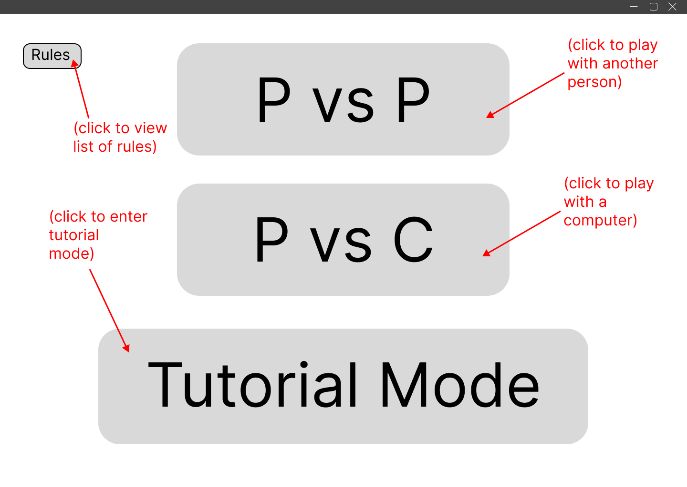

The Main Menu of the game that is shown when the game client is launched.

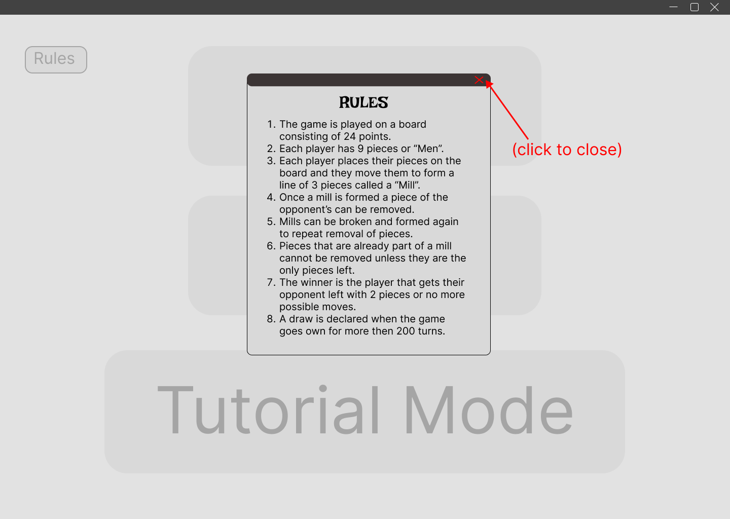

A list of Nine Men’s Morris game rules that can be viewed in at the main menu.

## **Main Game UI**

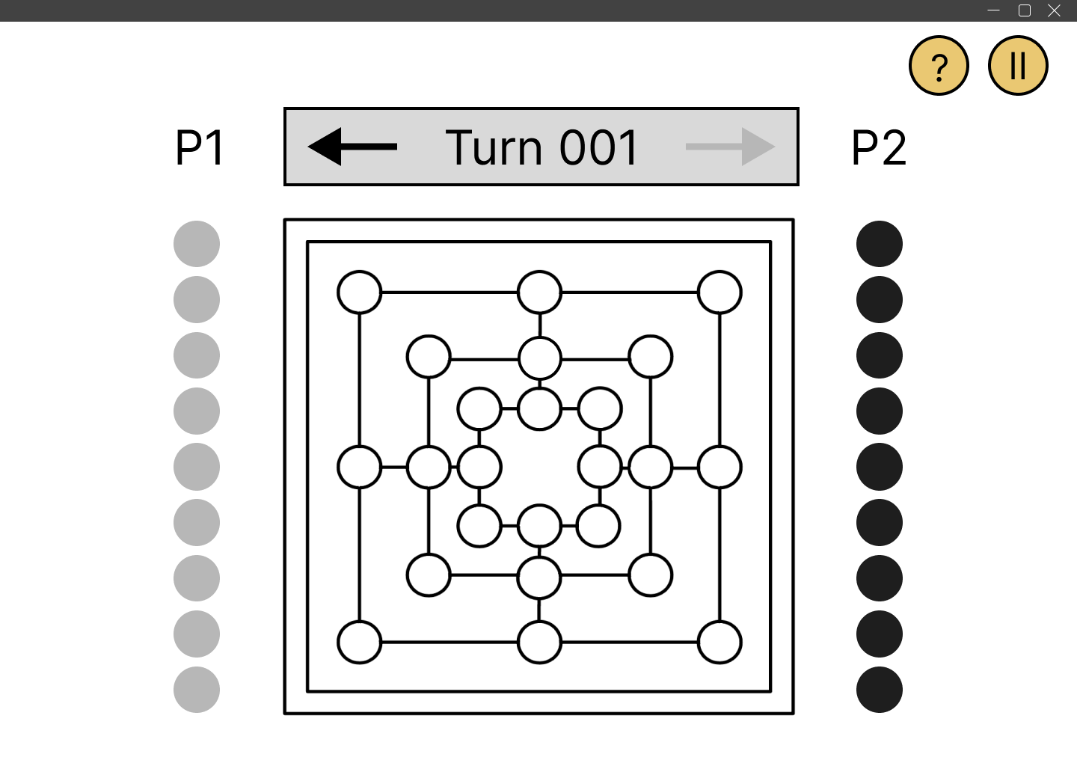

The UI of the game that is shown when the game starts.

## **Placing Phase**

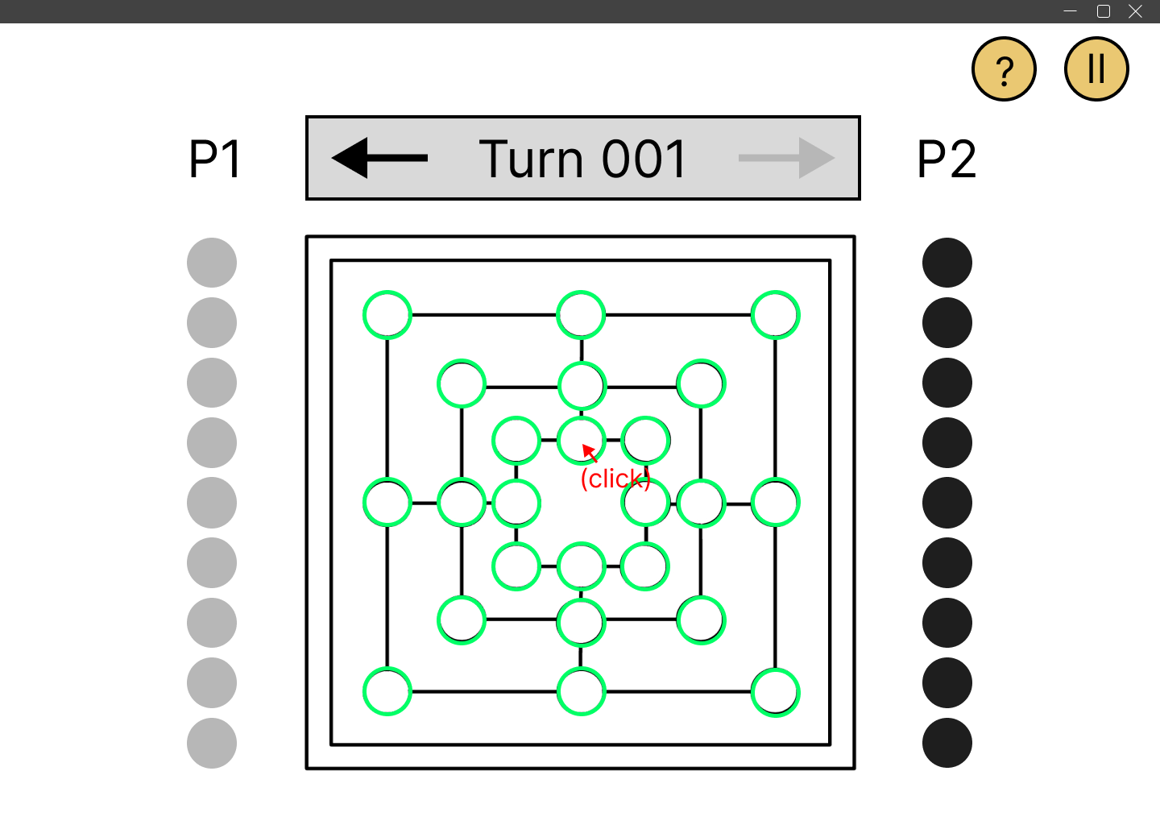

*Frame 1:* Green highlights indicate available position at the placing phase. Then a player can click on any of the position available.

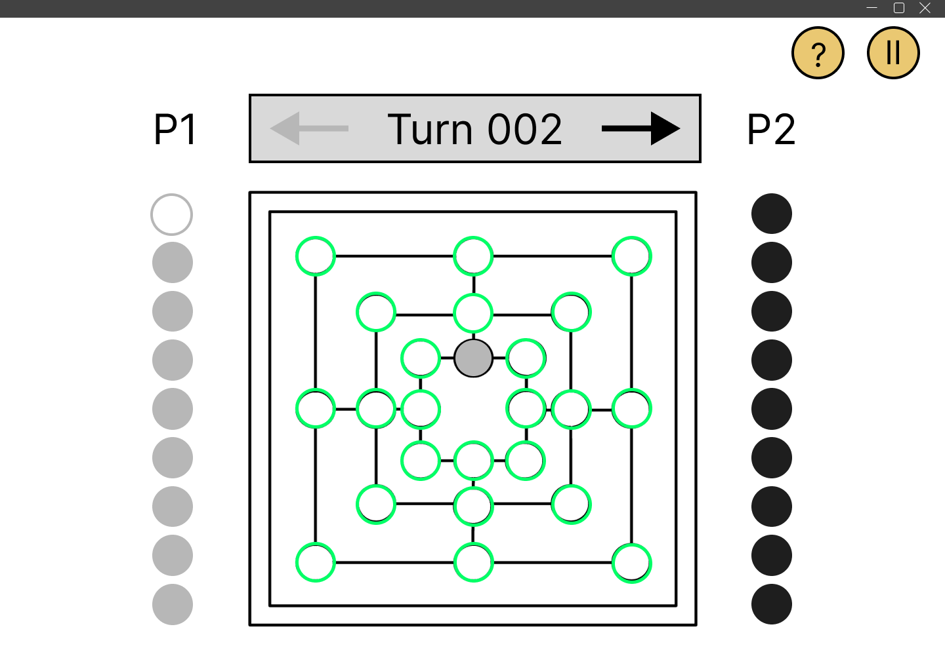

*Frame 2:* When a position is clicked, the player’s piece is automatically placed.

## **Moving Phase**

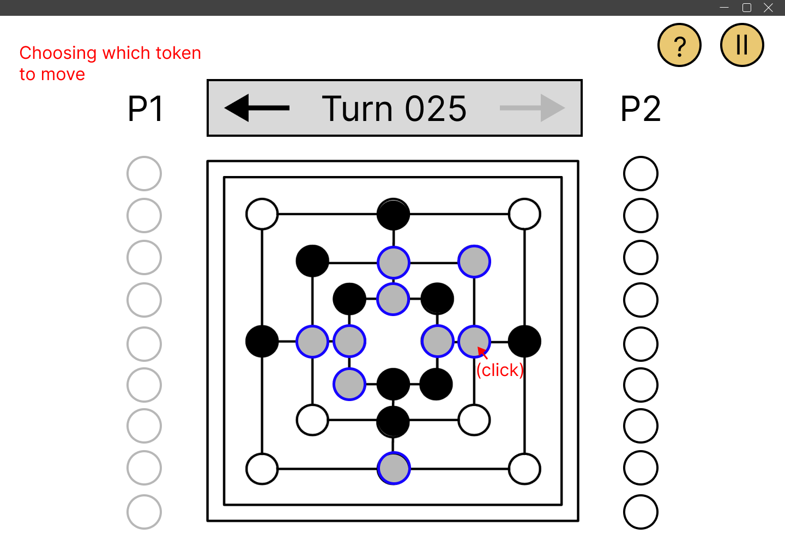

*Frame 1:* Blue highlights indicate available tokens to be chose. Then a player can click on the chosen token.

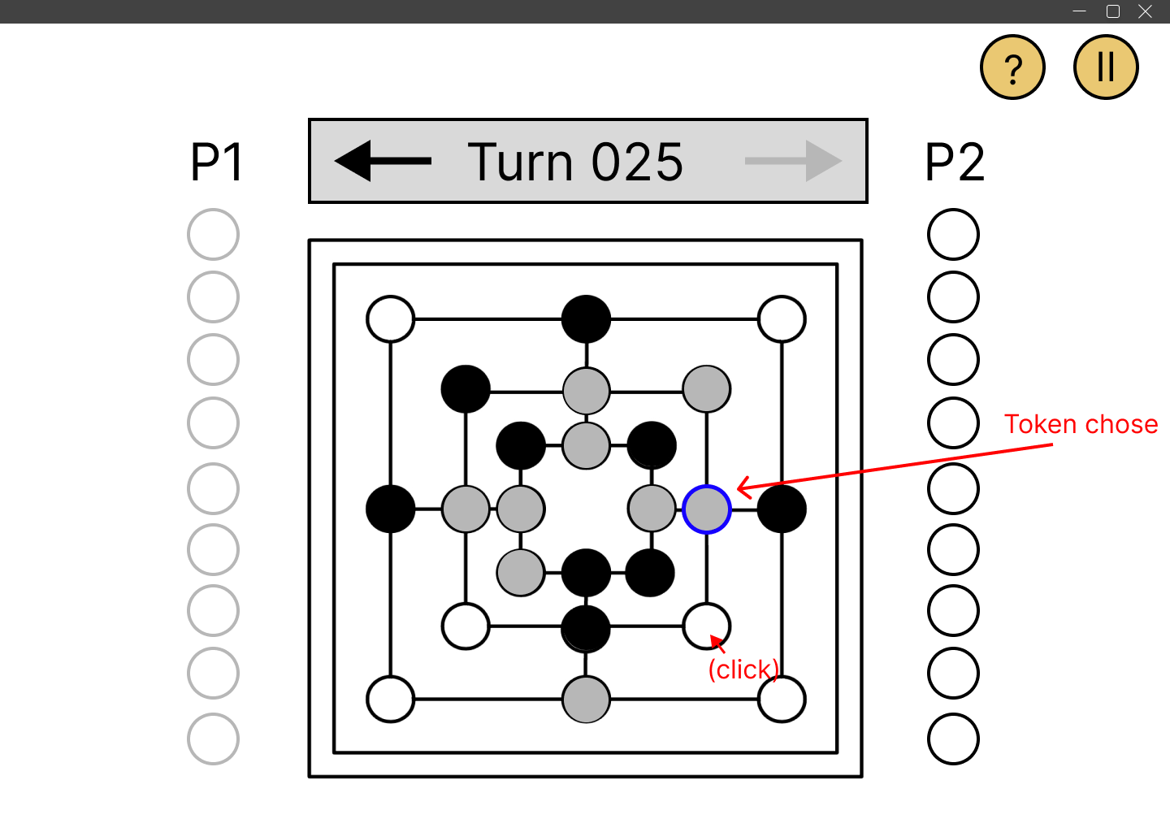

*Frame 2:* After choosing a token, the blue highlight on that token stays to indicate which token has been chosen. Then the player can click to choose a position for the token to be moved to.

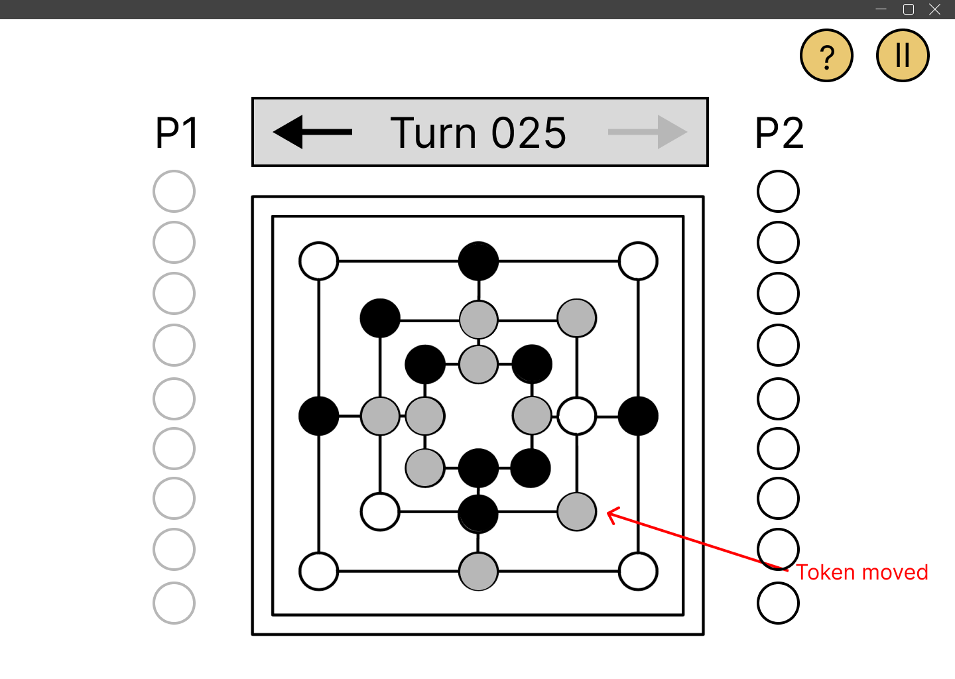

*Frame 3:* When a player has clicked on the position, the token will be automatically moved.

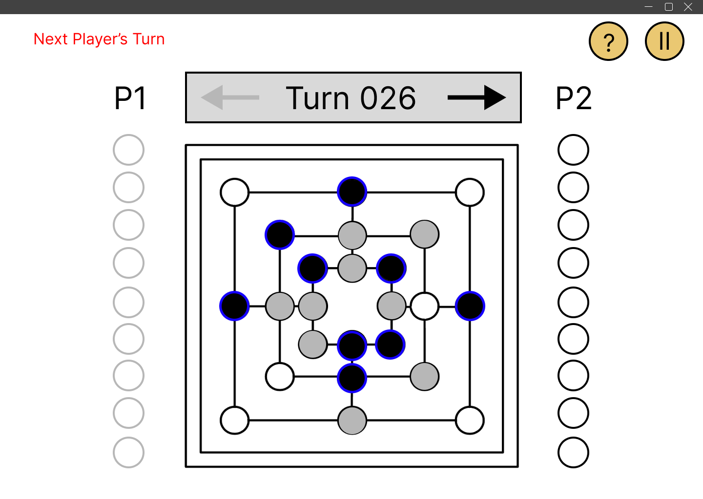

*Frame 4:* Then the turn changes and the same process repeats itself on the next player’s turn.

## **Flying Phase**

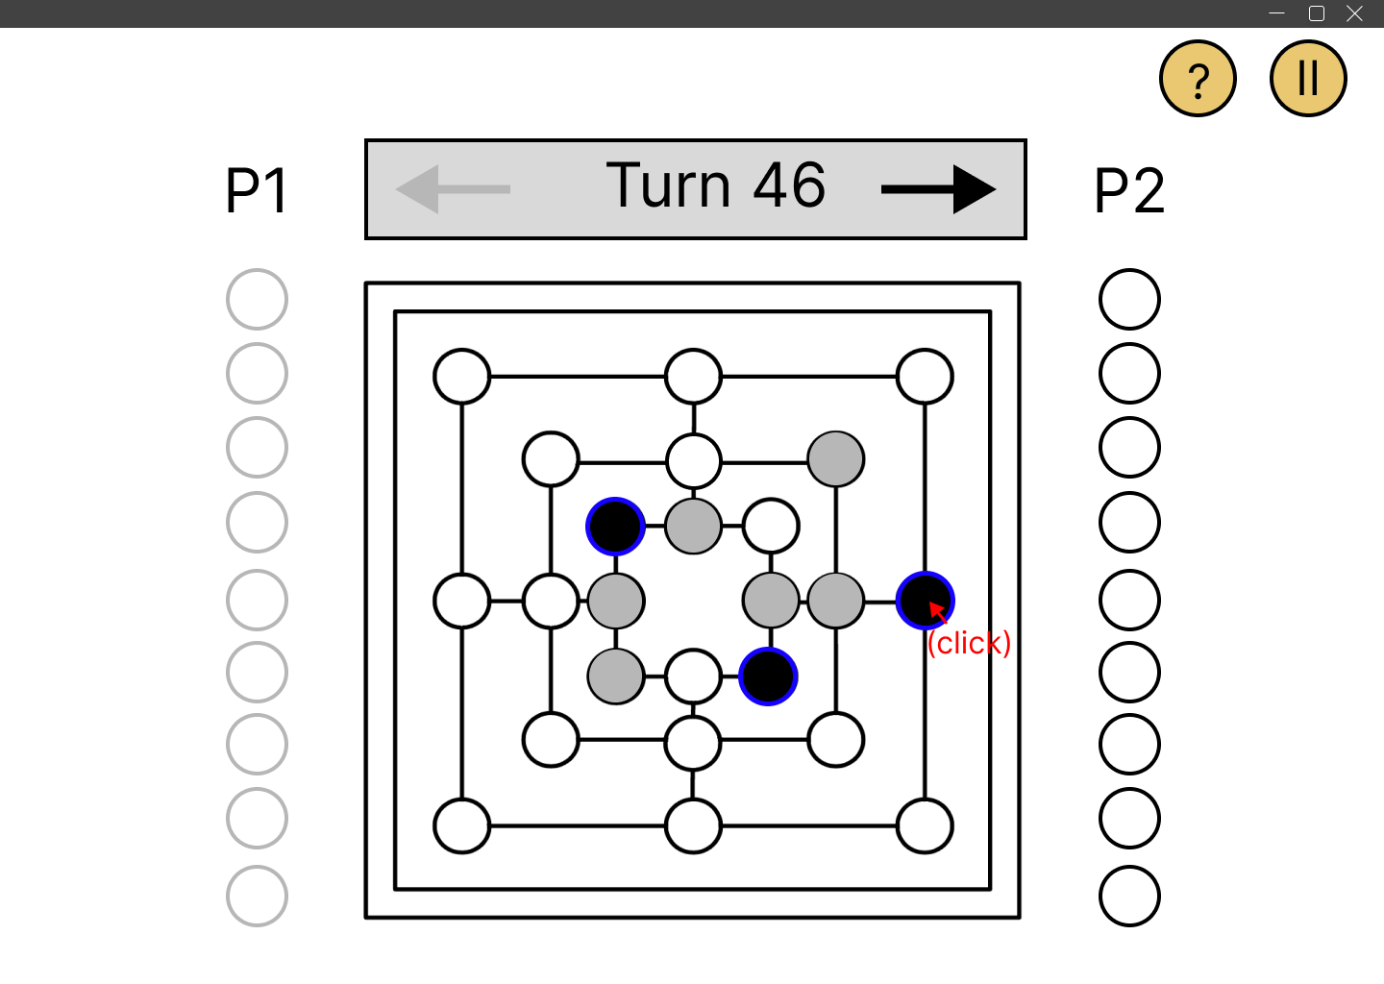

*Frame 1:* Blue highlights indicate available tokens to be chose. Then a player can click on the chosen token.

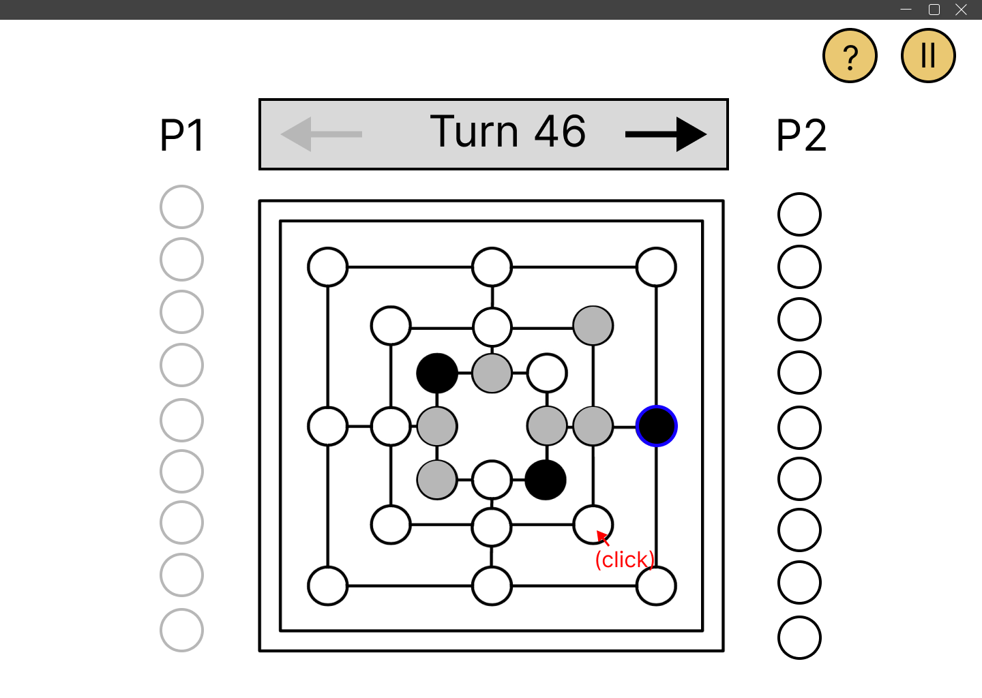

*Frame 2:* After choosing a token, the blue highlight on that token stays to indicate which token has been chosen. Then the player can click to choose a position for the token to be moved to.

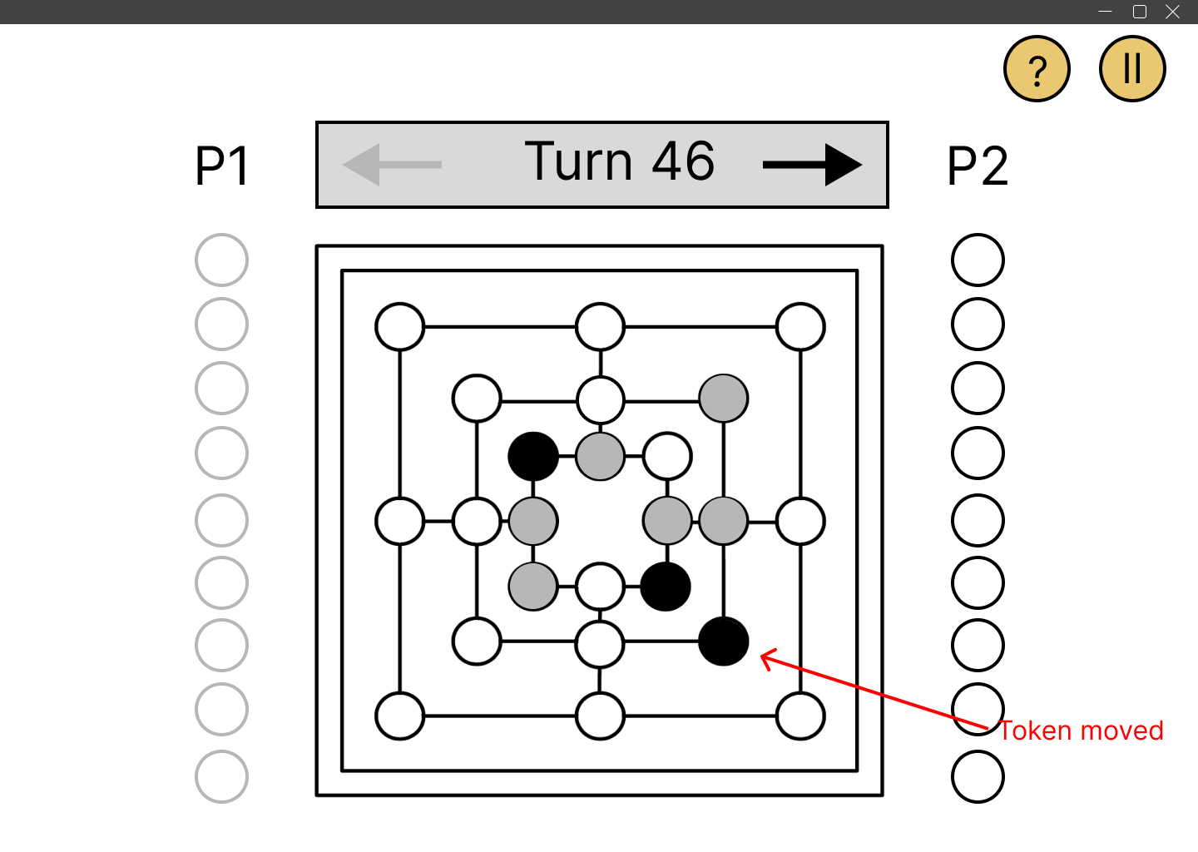

*Frame 3:* When a player has clicked on the position, the token will be automatically moved.

## **Forming a Mill and taking opponent’s token**

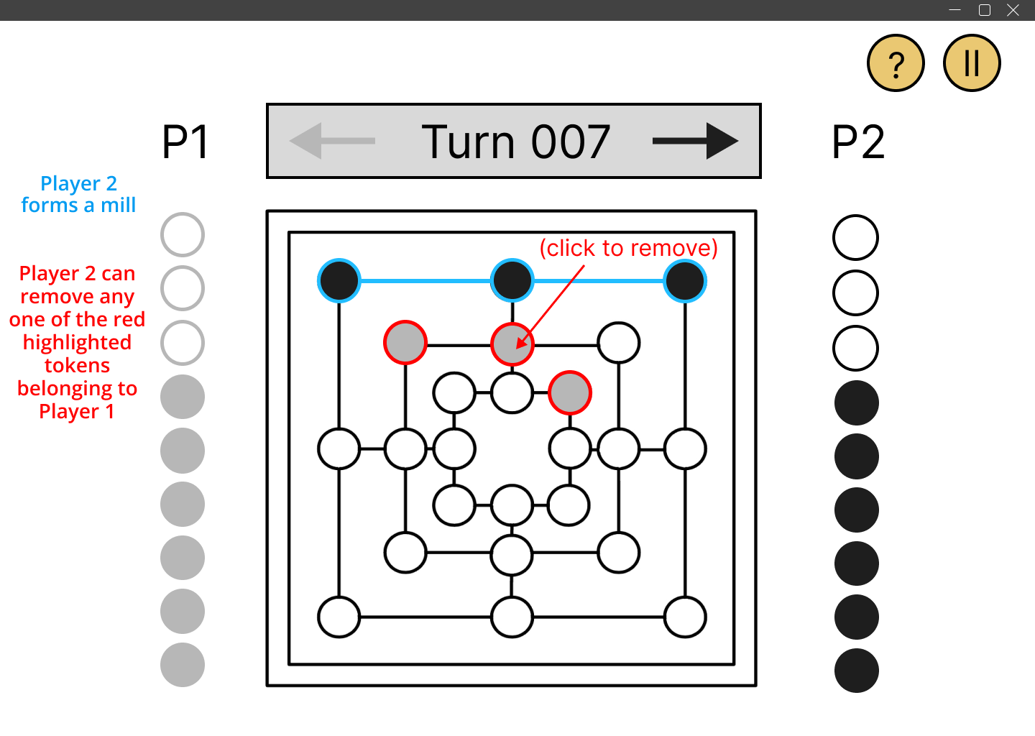

*Frame 1:* Player 2 forms a mill (shown in blue) since he has 3 tokens in a row.

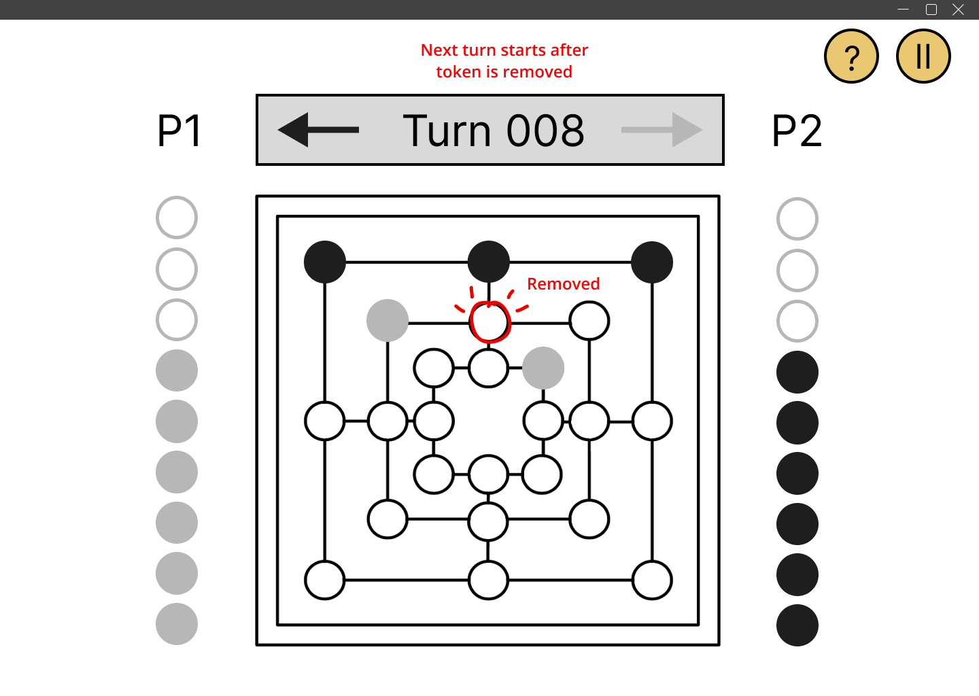

*Frame 2:* Player 2 removes one of Player 1’s tokens (shown in red) from the board by clicking on it. Removing the token ends Player 2’s turn.

## **Win/Loss and Game Draw**

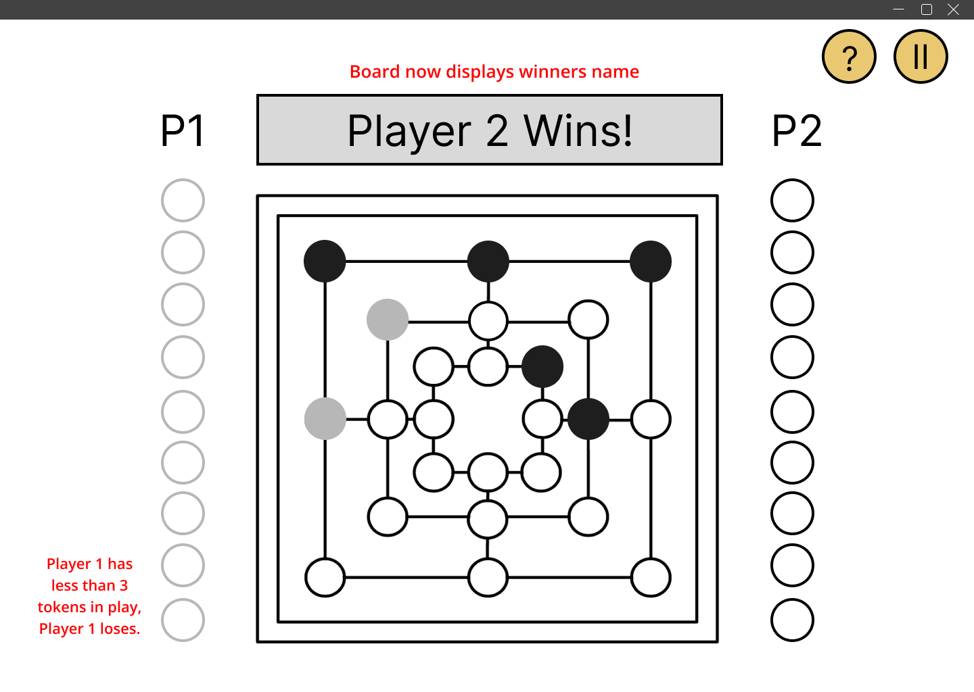

*Frame 1*: When any player has two tokens in play, it triggers the game to end. The turn indicator displays the name of the victor to indicate that the game has concluded.

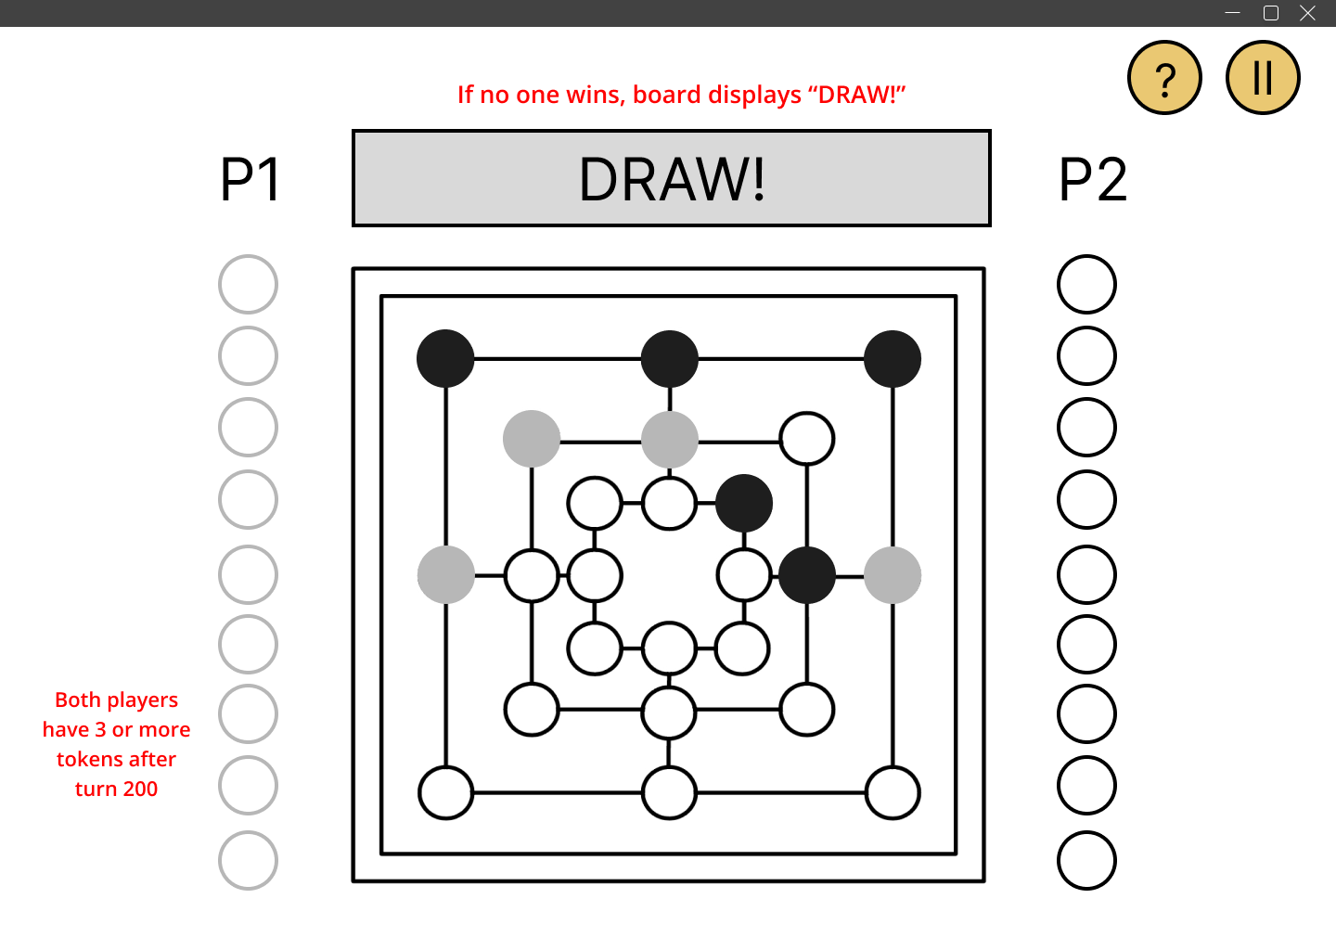

*Frame 2*: If both players have 3 or more tokens after turn 200, the game results in a draw. The turn indicator displays “DRAW!” to notify the players that the game has ended.

## **Tutorial Mode (Advanced Requirement(a))**

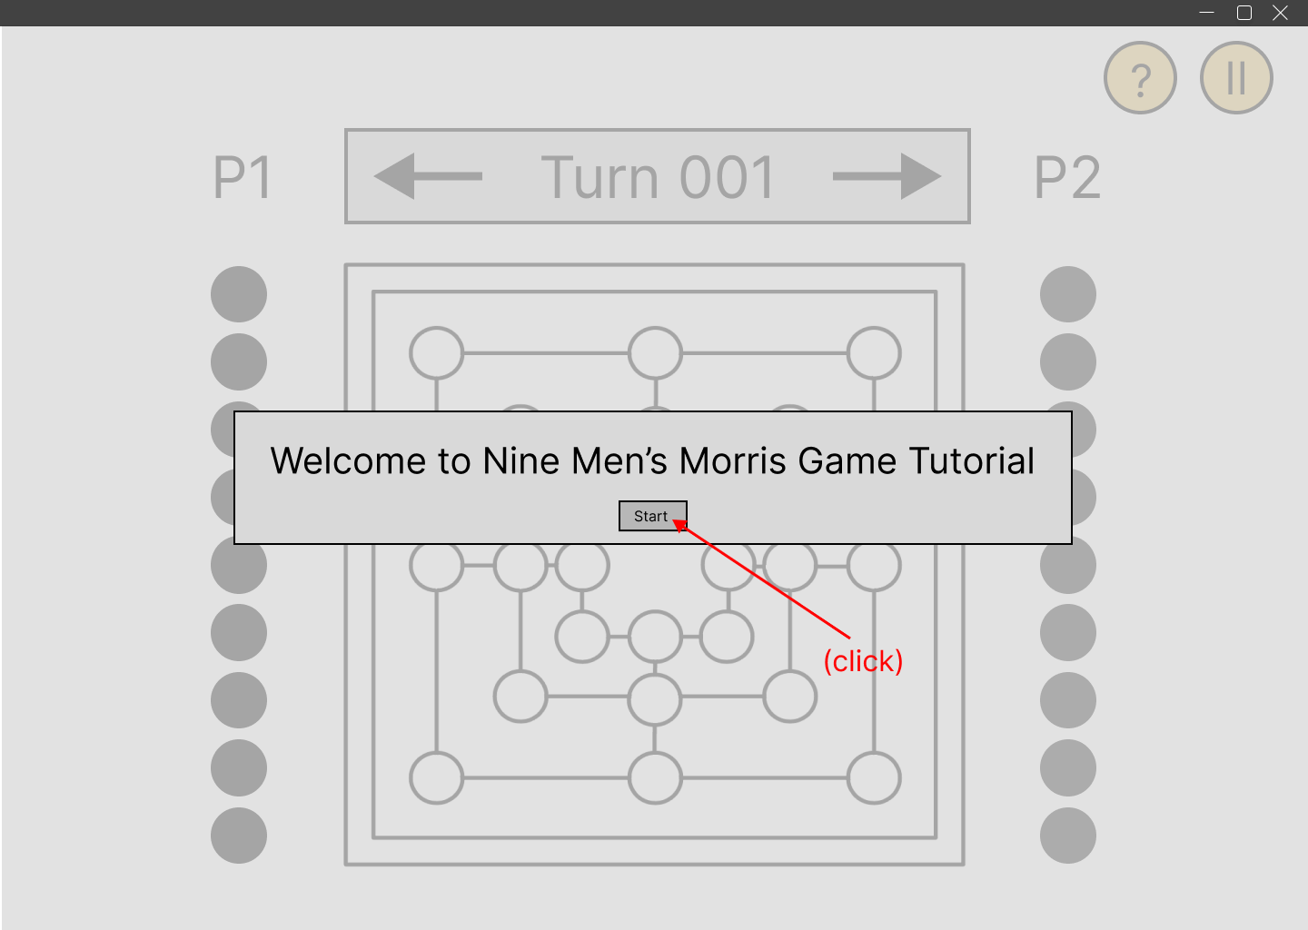

*Frame 1:* When a player clicks on the tutorial mode in the main menu, they are greeted with this screen and message to start the tutorial. The player clicks start.

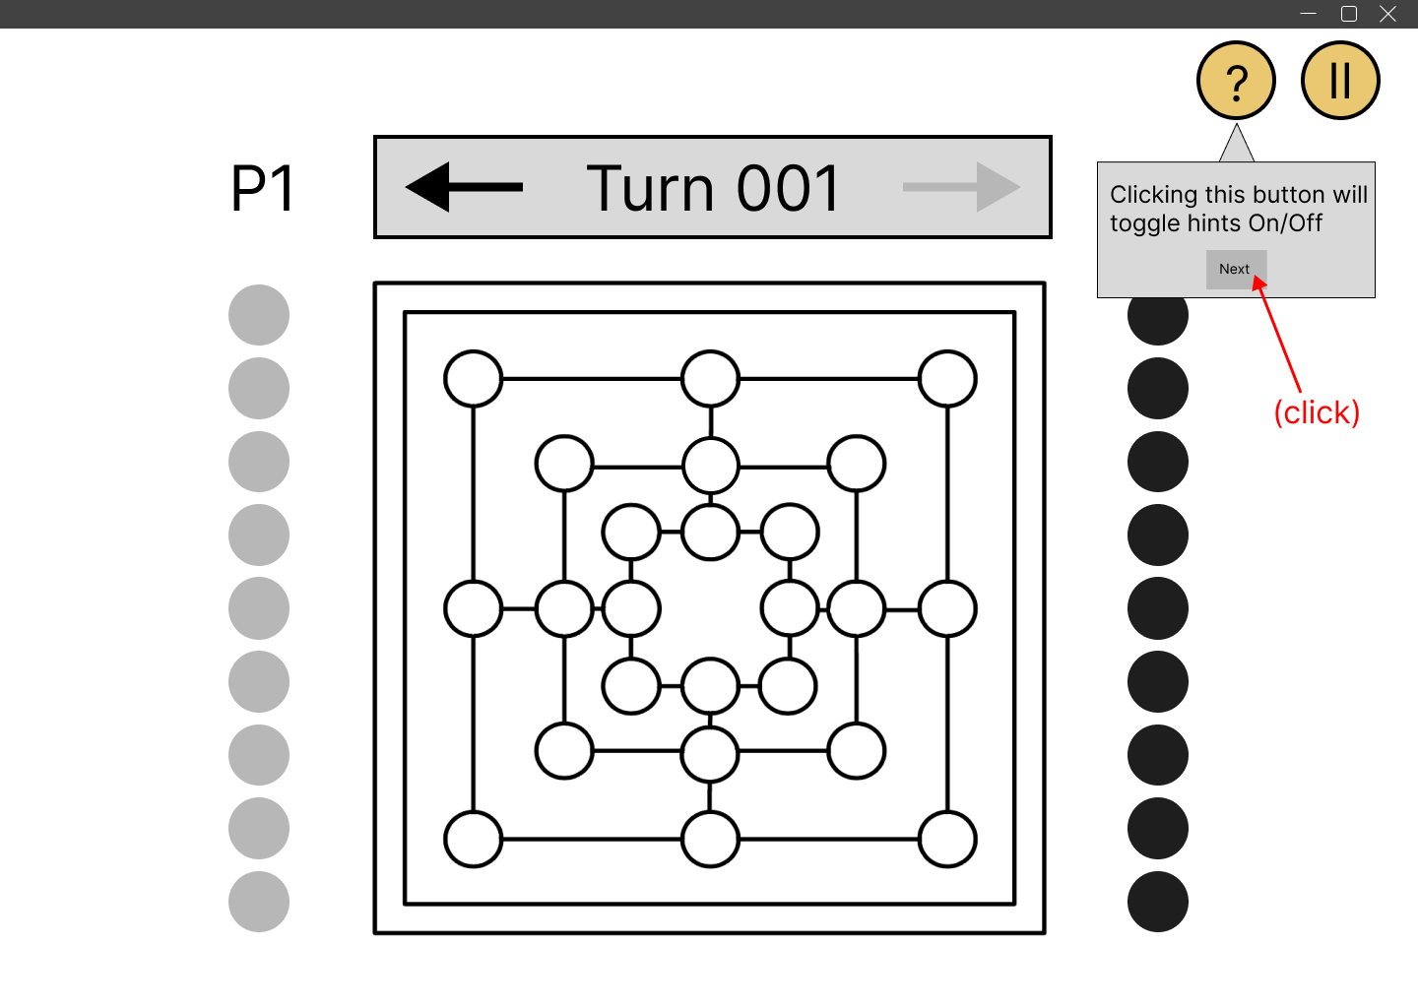

*Frame 2:* At the beginning of the tutorial a prompt box appears showing the player how to toggle hints on/off. The player clicks next.

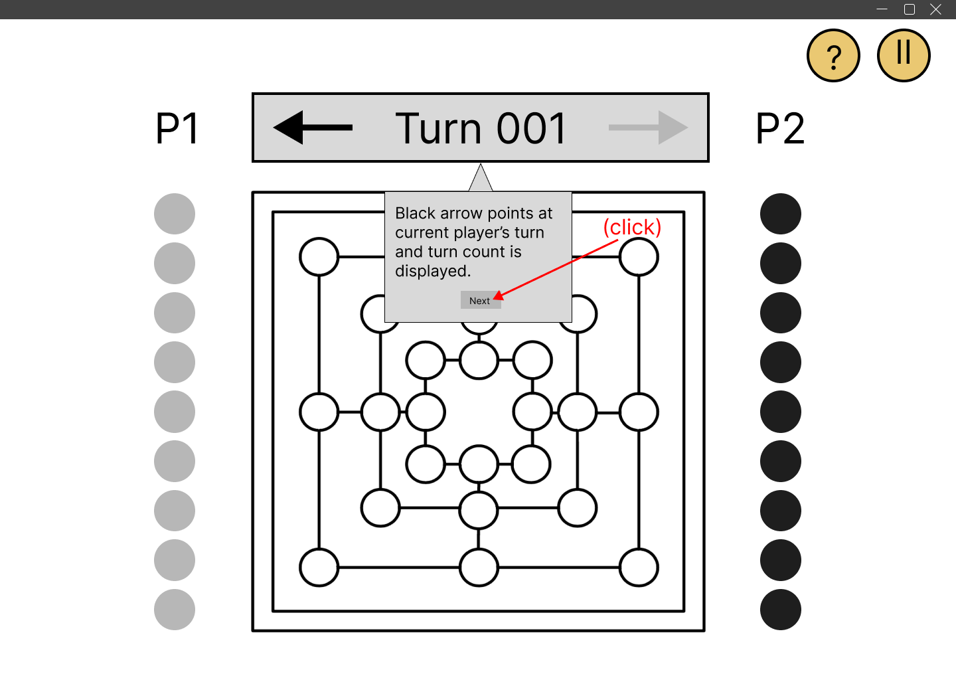

*Frame 3:* Next the prompt box explains the player what the rectangular box on top of the board indicates. The player clicks next.

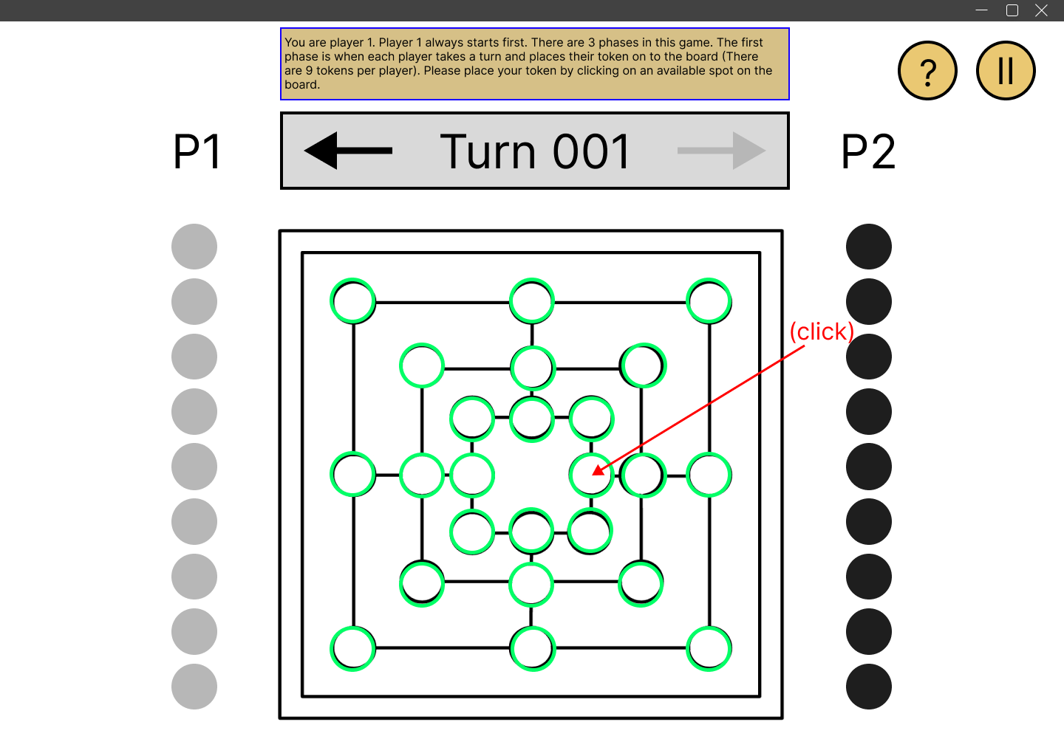

*Frame 4:* A note box at the top explains the rules gradually. For this instance, the player is told how to place a token. Player follows and places on the board by clicking.

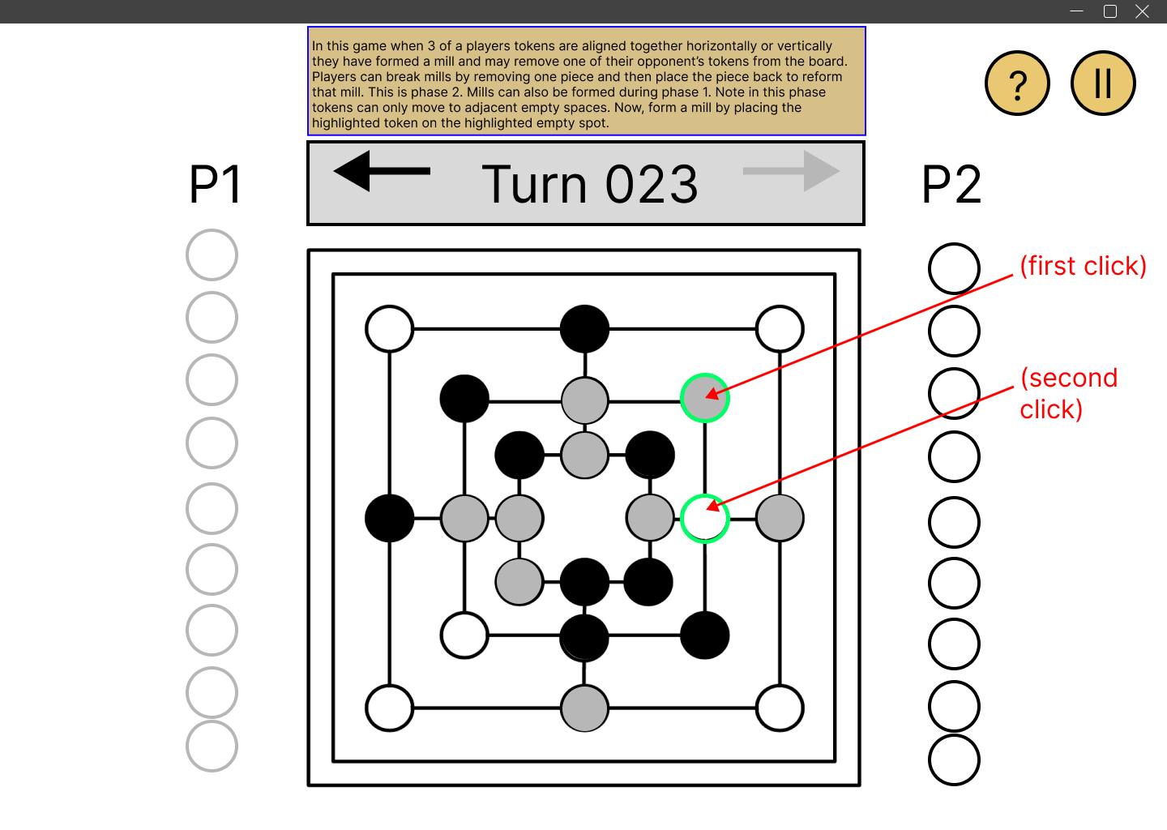

*Frame 5:* Player is taught how to move a piece to an available adjacent intersection and form a mill. Player follows clicks on the piece to move and clicks on the intersection for it to go on.

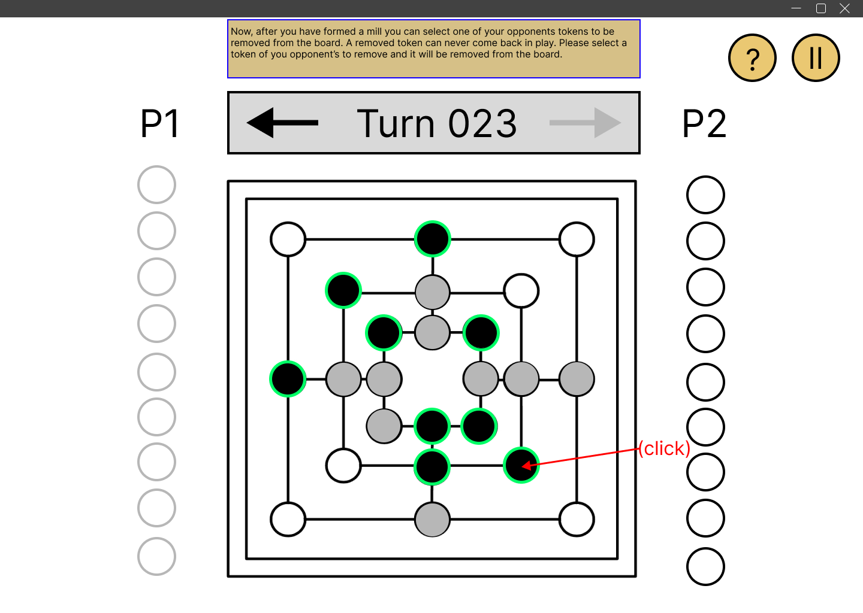

*Frame 6:* Player is taught how to remove an opponent’s piece from the board after forming a mill. The player follows and clicks on the opponent’s piece that is to be removed.

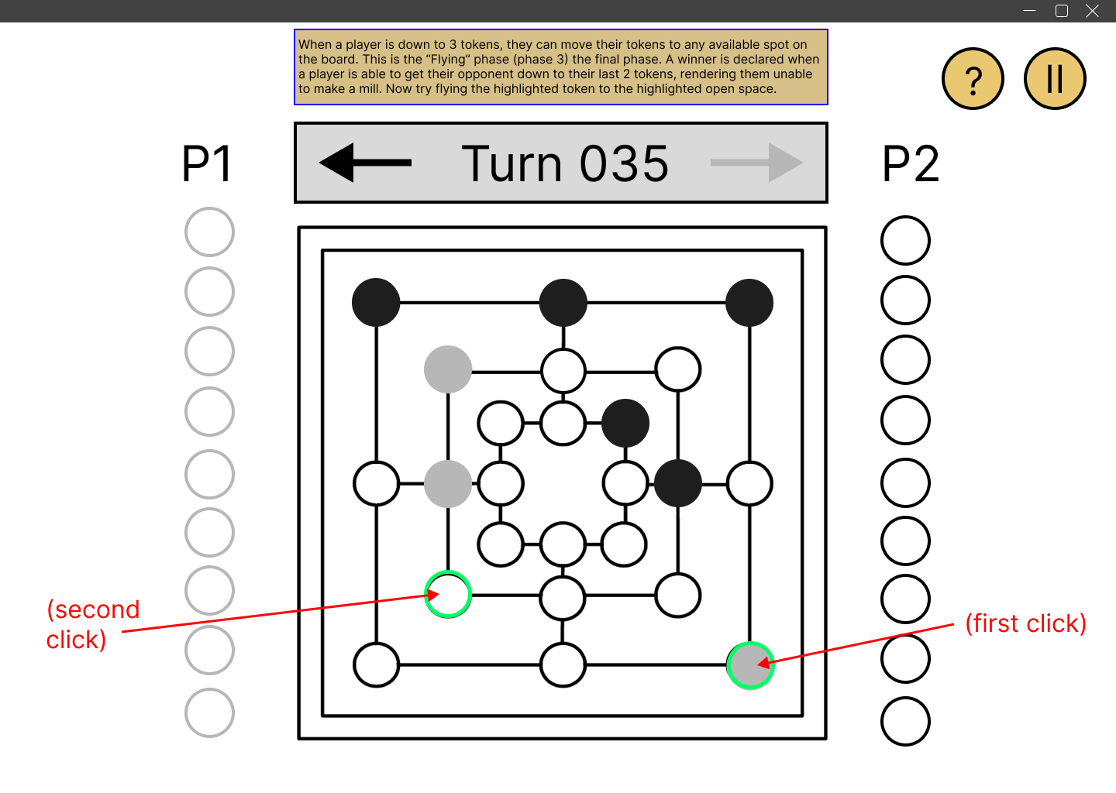

*Frame 7:* Player is taught how to fly a piece when they are down to three pieces. Player flies the piece by clicking an intersection on the other side of the board as highlighted by the tutorial.

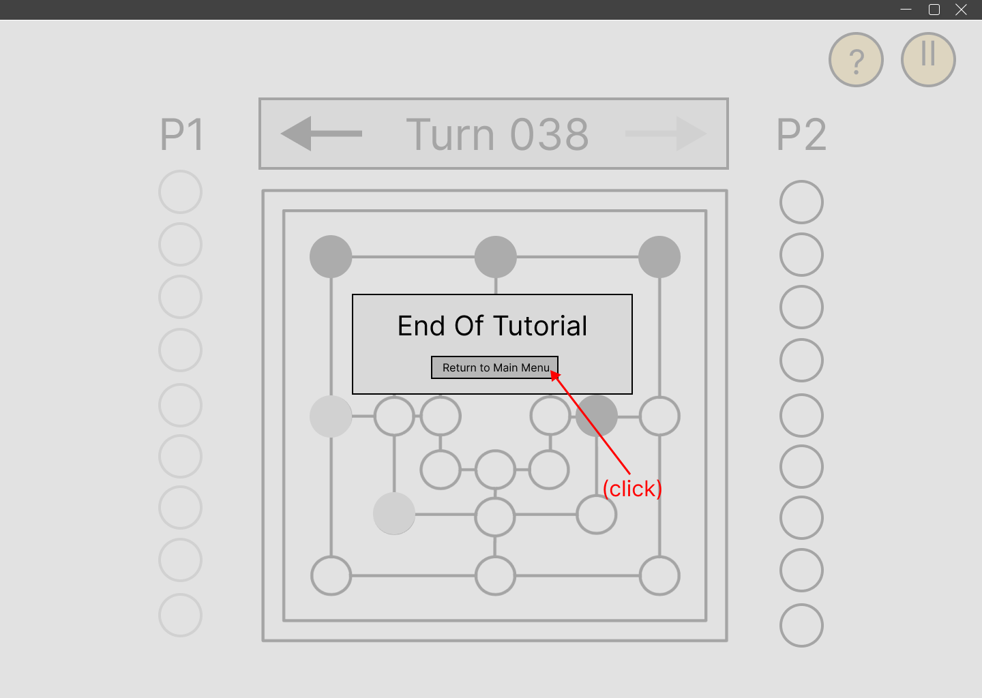

*Frame 8:* This concludes the tutorial and player returns to the main menu.

## **Toggle Hints (Advanced Requirement(a))**

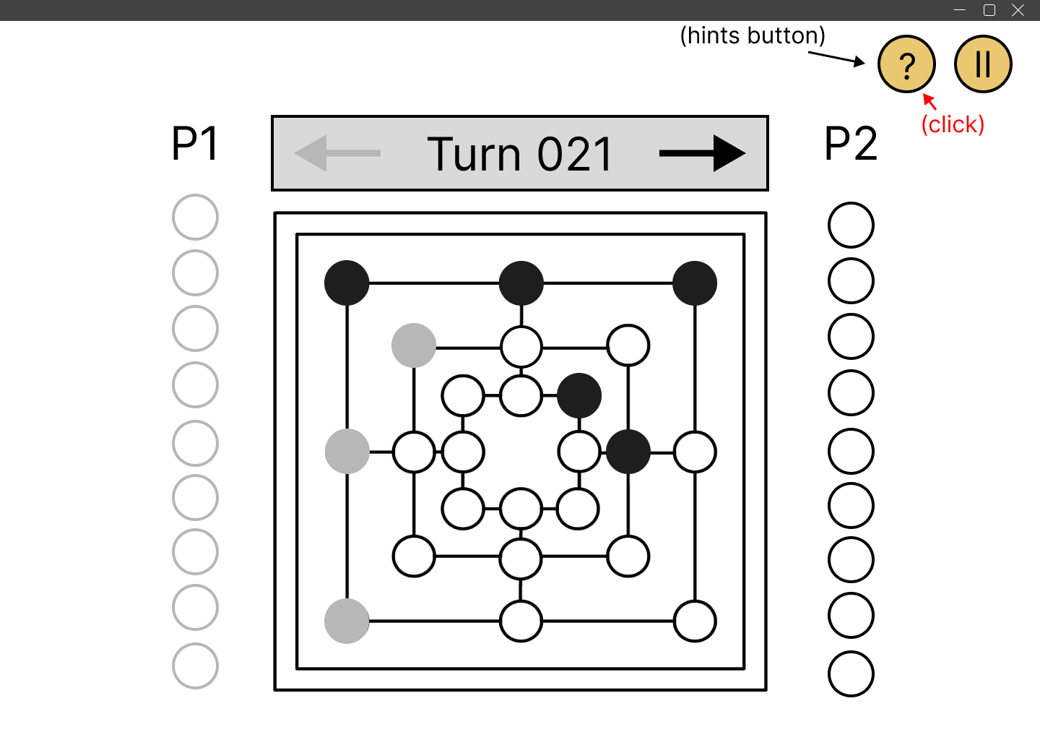

*Frame 1:* A button with a question mark toggles the hints on/off.

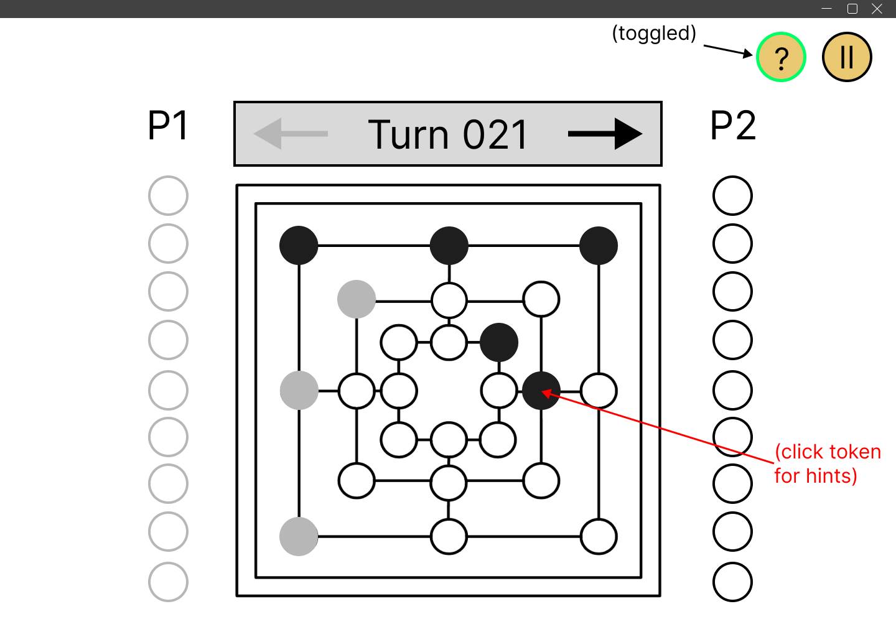

*Frame 2:* After toggling hints on the player whose turn is it can view all the legal moves of a piece by clicking them.

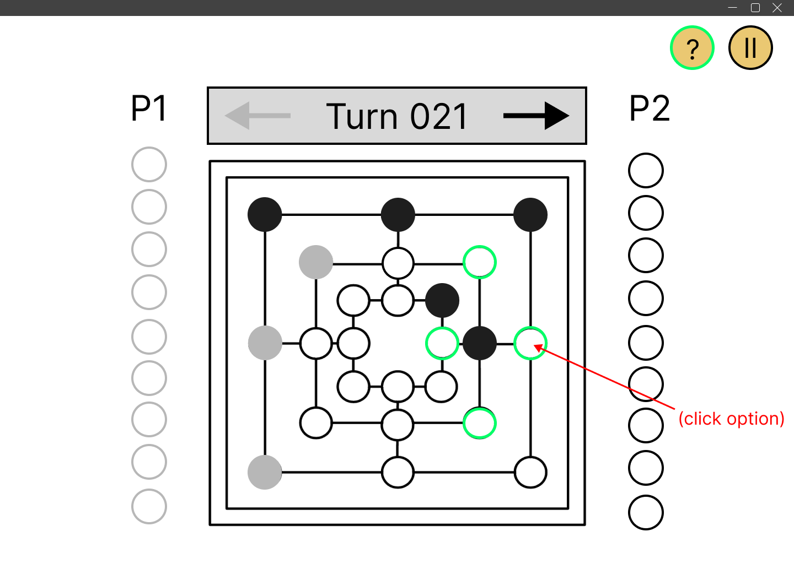

*Frame 3:* After the player clicks the piece the legal intersections that the piece can be moved to will be highlighted.

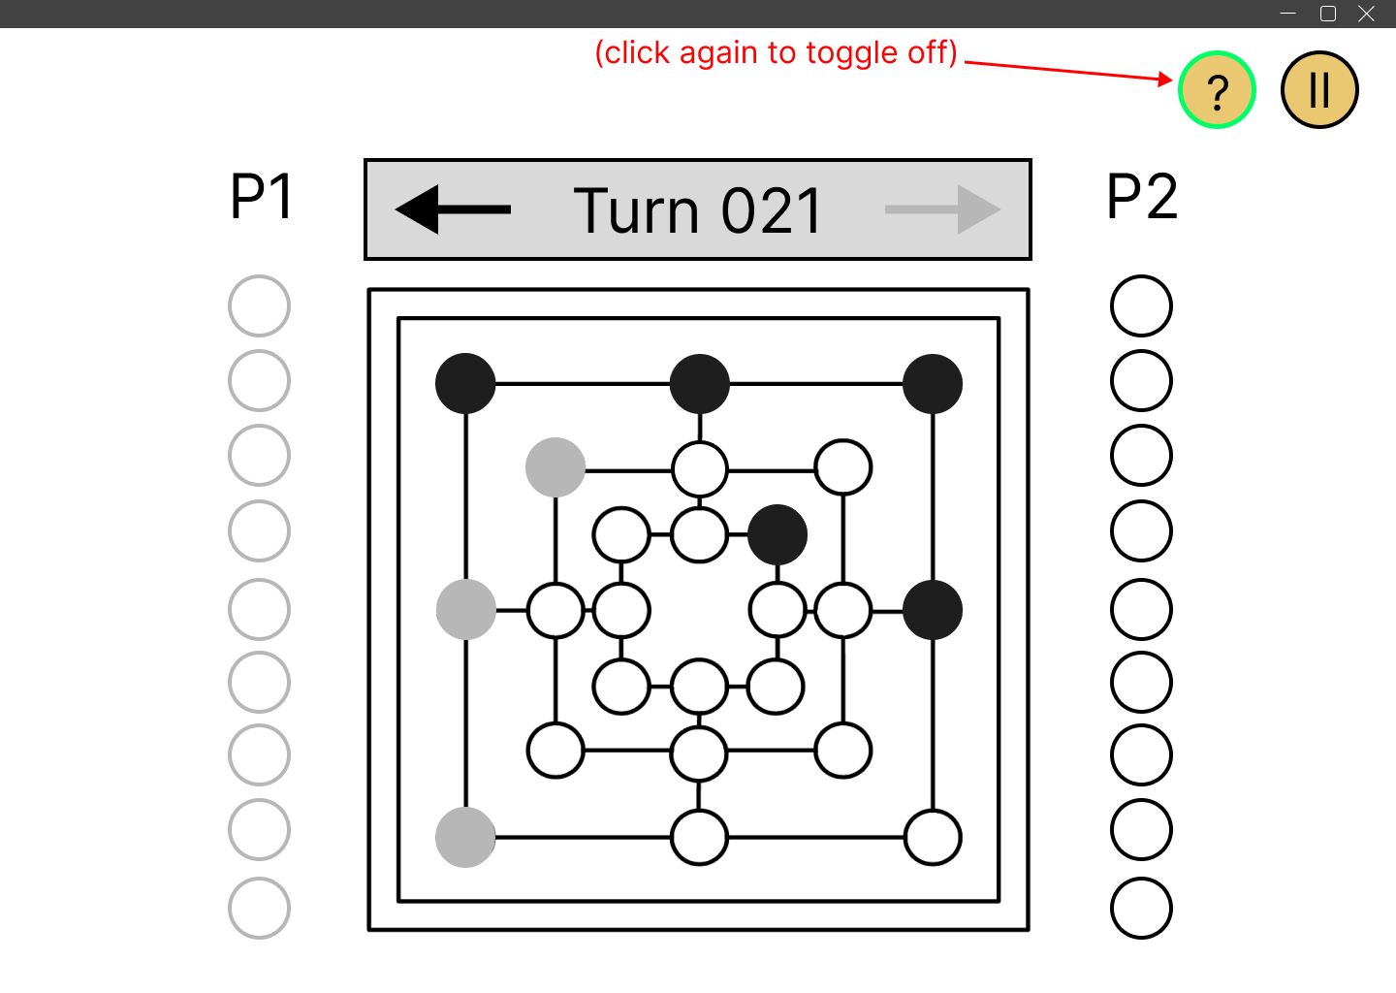

*Frame 4:* Clicking on the hints button again will toggle the hints off.

## **Computer Player (Advanced Requirement(c))**

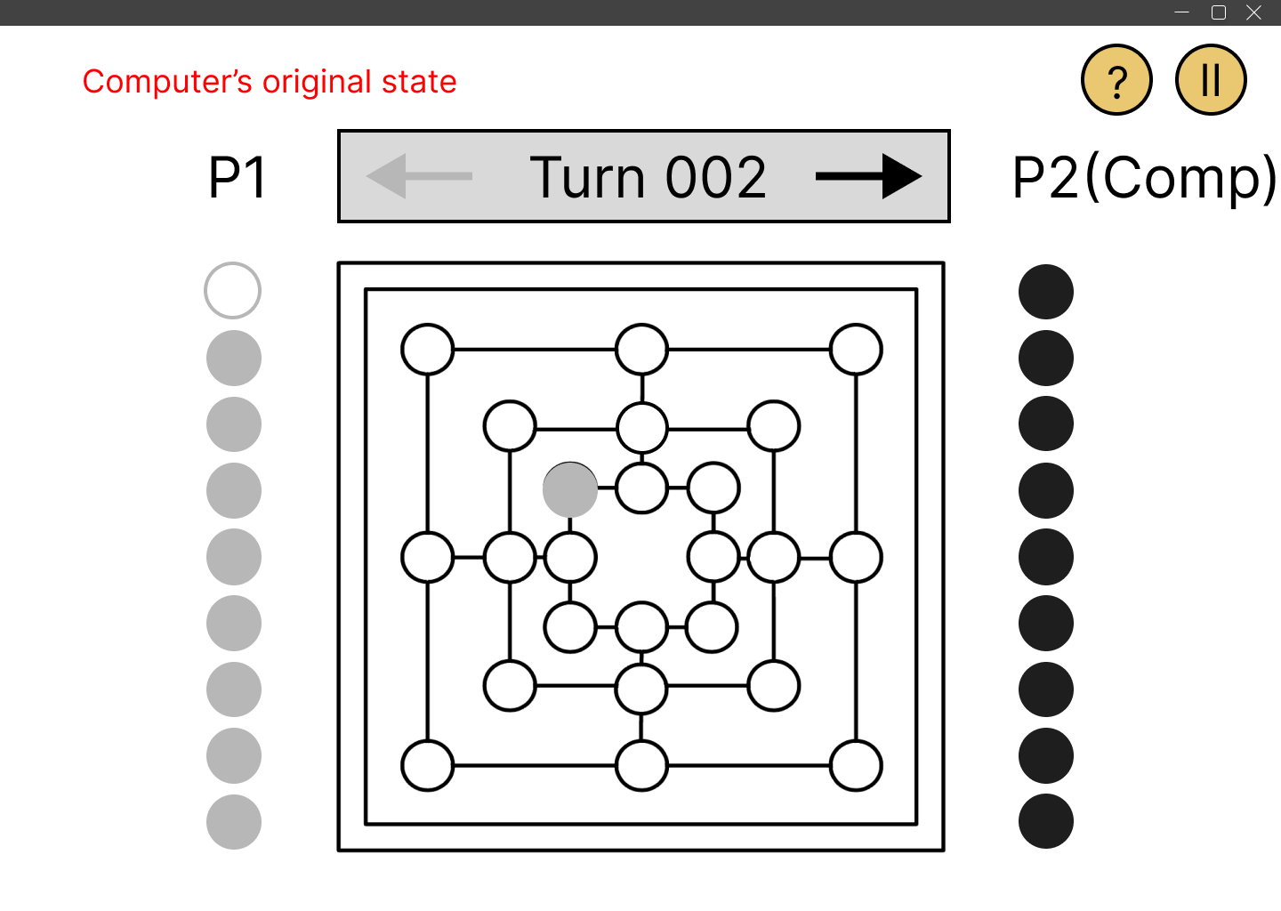

*Frame 1:* Player can play against computer by just clicking on P VS C in the main menu.

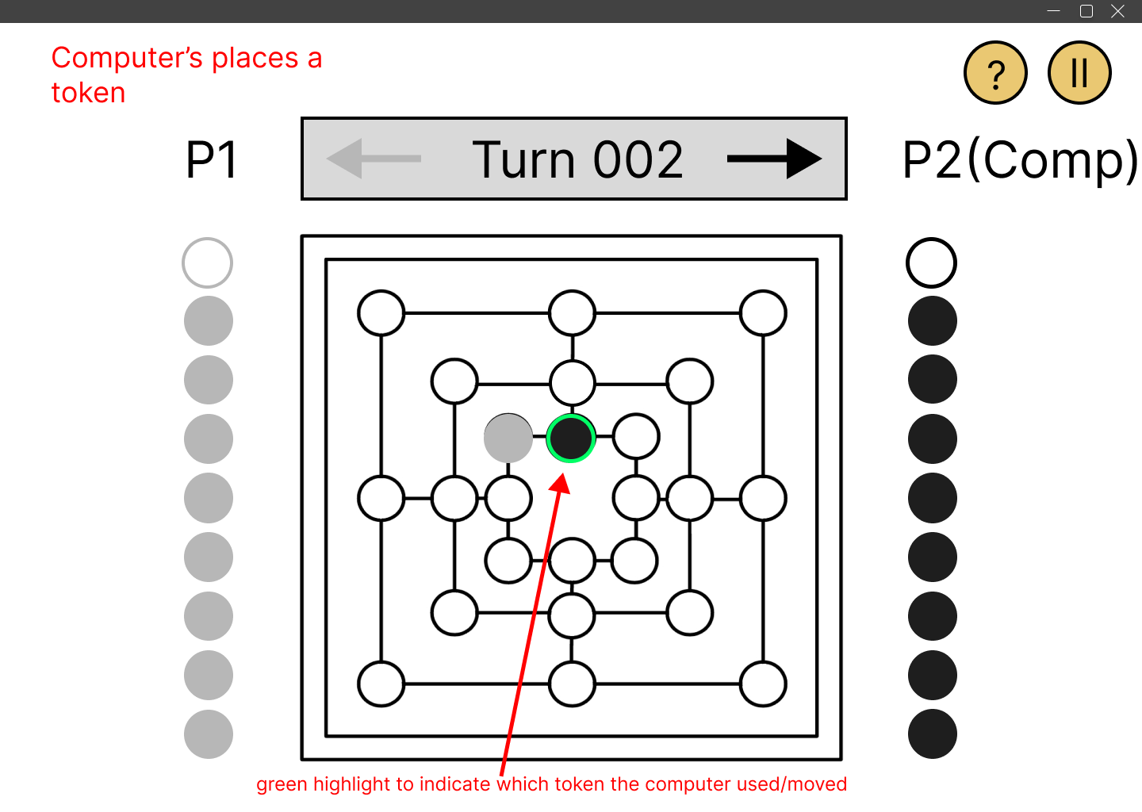

*Frame 2:* After human player plays their turn the computer automatically makes its move (legal) like a normal player.